Order Of Service

Singing: Psalm 103—CW page 105

Reading: Psalm 89:38-45

Opening Hymn: TLH 492

Reading: Acts 16:16-24

Request Hymn: CW Supplement 750

Reading: Matthew 5:31-37

Sermon Hymn: TLH 482

Sermon Text: Mark 3:13-19

Up Into A Mountain

Prayer

The Apostles’ Creed, TLH page 12

Holy Communion

The Lord's Prayer

The Blessing

Closing Hymn: TLH 52

* * * * * * * * * * *
Bible Study: Lambs: Sequoia
Sheep: Proverbs 15:30-33


Winter In The Tropics

Water
Of
Life
13 January 2019

W A T E R O F L I F E

Independent Christian Church—Conservative Lutheran Doctrine

Worship Service: 9:30 a.m. Bible Study: 10:45 a.m.

Larry Cooper, Pastor E-Mail address:
111 N. Ridge Road lcooper@wateroflife.cc
Coon Valley, WI 54623 Web Site:
www.wateroflife.cc

* * * * * * * * * * * * * * * * * * * * * * * * * * *

Sermon Text: Mark 3:13-19

Up Into A Mountain

* * * * * * * * * * * * * * * * * * * * * * * * * * *

Mark 3:13 And he goeth up into a mountain, and calleth unto him whom he would: and they came unto him.
:14 And he ordained twelve, that they should be with him, and that he might send them forth to preach,
:15 And to have power to heal sicknesses, and to cast out devils:
:16 And Simon he surnamed Peter;
:17 And James the son of Zebedee, and John the brother of James; and he surnamed them Boanerges, which is, The sons of thunder:
:18 And Andrew, and Philip, and Bartholomew, and Matthew, and Thomas, and James the son of Alphaeus, and Thaddaeus, and Simon the Canaanite,
:19 And Judas Iscariot, which also betrayed him: and they went into an house.

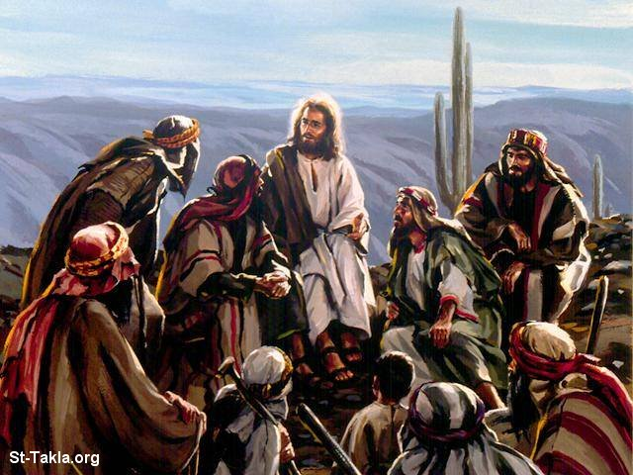

Related Passages:

John 15:16 Ye have not chosen me, but I have chosen you, and ordained you, that ye should go and bring forth fruit, and that your fruit should remain: that whatsoever ye shall ask of the Father in my name, he may give it you.

Ezekiel 2:1 And he said unto me, Son of man, stand upon thy feet, and I will speak unto thee. :2 And the spirit entered into me when he spake unto me, and set me upon my feet, that I heard him that spake unto me.

